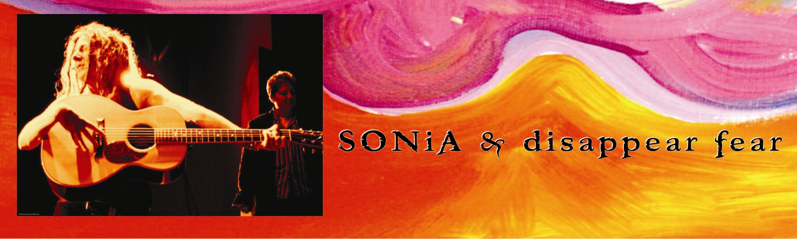
Whether in the bomb shelters "Miklats" in Israel or summer camps in Palestine, Human Rights Events, Colleges, Festivals or Venues around the world SONiA is always striving to disappear fear and spread her message of Peace. In fall 2007 SONiA released a new CD with her band ‘disappear fear’ to the world (al mundo). “t a n g o" features 13 songs in Spanish, Hebrew, Arabic and English. The music matches the words in poetry about Love, Peace and Equality; themes familiar to SONiA's writing since the creation of ‘disappear fear’. “t a n g o” has been classified as WORLD and Folk-Pop. Latin and Middle Eastern rhythms and instrumentation along with lush string arrangements and harmonies are featured. SONiA & disappear fear began a coast to coast tour of the USA and Canada with the launch of the CD this fall and will end 2007 in Australia.
Sisters SONiA & CiNDY [Rutstein] of Baltimore Maryland created the Folk-Pop duo disappear fear and signed with Carlin Publishing in London almost immediately. After releasing three albums on their own they signed with Warner Chappell Publishing and Rounder Records in 1994 for the release of their self-titled CD. The CD won multiple awards including the GLAAD Award for Best Album, a GLAMA award, and Top Release of the Year by Mix Magazine. The next release, "Seed in the Sahara", was produced by Springsteen's piano player, Roy Bittan and won the GLAMA for best band. In 1998, with CiNDY off the road as a full time Mom, Rounder released "Almost Chocolate", SONiA's first solo CD under her own name. During that year SONiA toured Europe (Denmark, Sweden, and the Netherlands) and Australia for the first time. "Me,Too" her 1999 release won Female Artist of the Year at the GLAMAs. "Me,Too" was also later chosen by the HRC (Human Rights Campaign) along with songs by U2 and many others for their compilation CD. "Me,Too" was also chosen by the Philadelphia Folk Festival for their 40th Year Anniversary CD (along with Ritchie Havens). Following another solo release "Live at the Down Home", SONiA released “No Bomb Is Smart” to rave reviews and a nomination for “Best Contemporary Folk”. She decided it was time to bring back the harmonies which disappear fear has always been known for and added Laura Cerulli on vocals, percussion and drums. With Laura and other musicians SONiA & disappear fear released DF05 in 2005.
SONiA has written several soundtracks for films including the 2006 documentary Autumn’s Harvest directed by Dave Marshall. The film is playing at film festivals around the world. She is currently working on a musical that will be released in 2009 as well as a Blues CD. When not on the road SONiA does commissioned artwork, including paintings and large murals.
SONiA & disappear fear will continue to share their music around the world in 2008 with tours in Australia, the USA, Canada, Europe, Asia, Israel, and the Middle East. Their label disappear records donates 18% of every song downloaded to the United Nations World Food Programme to help end poverty around the globe. In keeping with her message of global harmony SONiA has created ”Guitars for Peace” which helps bring Acoustic Guitars to children in war torn countries. Two guitars have already been delivered.
MANAGEMENT & BOOKING:  Terry Irons  410.372.0807  terry@disappearfear.com | SONiA & disappear fear  P.O. Box 10435  Baltimore, MD 21209  www.disappearfear.com | TOUR PRESS,TV & RADIO:  Nancy Palmquist  410.913.2773  nancy@disappearfear.com

