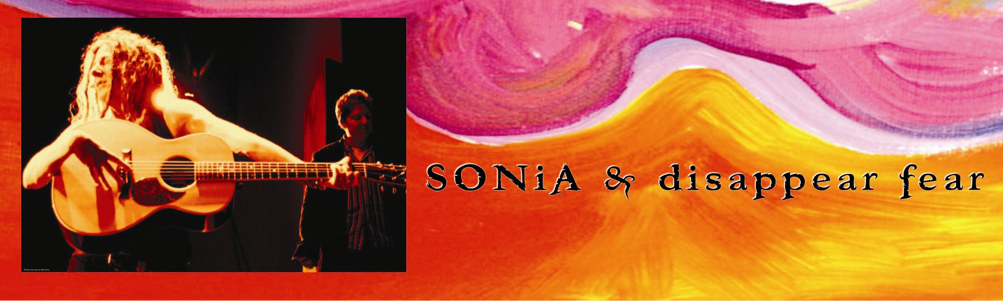
DISCOGRAPHY:  SONiA & disappear fear: t a n g o produced by John Grant and SONiA  SONiA: No Bomb is Smart:Dance Mix Singles produced by Blake Althen  SONiA & disappear fear: DF05 LiVE  SONiA: No Bomb is Smart produced by Craig Krampf  SONiA: Live at the Down Home recorded by Phil Leonard  SONiA: Me, Too produced by SONiA and John Grant  SONiA: Almost Chocolate produced by SONiA and Danny Bernini  disappear fear: Seed in the Sahara produced by Roy Bittan  disappear fear: disappear fear produced by Craig Kramph  disappear fear: Live At the Bottom Line produced by disappear fear, Tom Purak and John Grant  disappear fear: Deep Soul Diver produced by John Grant and disappear fear  disappear fear: Echo My Call produced by SONiA, Cindy Frank & John Grant  FAVORITE VENUES & FESTIVALS:  The Down Home, Jazzhaus, Birchmere Music Hall, Gravity Lounge, Wolftrap Barns, The Bottom Line, The Bluebird Cafe, 8x10, The Iron Horse, Kuumbwa Jazz Center, Great American Music Hall, Eddie's Attic, Freight and Salvage, Margaritaville, HardRock Cafe-Washington, DC, KiMo Theatre, Royce Hall, The Paramount Theater, The Mercury Lounge, Club Passim, The Tractor Tavern, The Tin Angel, The Ram's Head, Blind Pig, 12th and Porter, Blueberry Hill, Manhattan's, Grey Eagle, Rosebud, Old Towne School, Schuba's, The Ark, CSPS, Blue Moon Cafe, Canal Street Tavern, Palms Playhouse, Mucky Duck, Mike’s Place, Black Cat, 930 Club, Cafe Lena, Maxwells, First Encounter, Turning Point, Gordon Center, Woodford Folk Festival, Summerfolk Festival, Vancouver Folk Festival, Falcon Ridge Folk Festival, Amnesty Intenational Film Festival-Tel Aviv, Olympic Cultural Events - Sydney, Clearwater's Great Hudson Revival, Sailfest, Lilith NC shows, Boston's Women in Folk and Rock, Woodstock #2; Many Phil Och's Nights in the USA and AUS, Apple Farm Folk Festival, Riverbend Festival, World Games-Amsterdam, Philadelphia Folk Festival, Winnipeg Folk Festival, Pittsburg Pride Celebration,Vancouver Pride, Michigan Womyns Music Festival, SOHO Arts Festival, Marches on Washington (NOW Rally), WorldPride-Jerusalem, Atlanta Pride, Baltimore Pride, Boston Pride, Carborro Pride, Cape Cod Pride, Delaware Pride, Las Vegas Pride, Cincinnati Pride, Cleveland Pride, LongBeach Pride,Jacksonville Pride, Portland Pride, San Diego Pride, San Francisco Pride; St. Louis Pride, Washington DC Pride, NOW Summit-Washington DC, Europride, Stockholm's 50th Anniversary of Gay Rights, International Conference on Women-Helsinki, Stonewall 25-Central Park NY, Maryland State Fair, Baltimore City Fair, Susquehanna Music and Arts Festival, Montana Intl. Jazz and Blues Festival, High Sierra Music Festival, Kerrville Folk Festival.  AWARDS & ENDORSEMENTS:  JEEP Chrysler named SONiA for a national ad and tour to launch the new Jeep Compass  Santa Cruz Guitar SONiA Model and Parker Guitar- Concert Fly, AUDIX Microphones,  SHUBB Capos, D'Addario Strings, ORBITZ Travel, Fishman & B-Band pickups, Earbuzz Song of the Year 2006 - Won’t Let Go; GLAMA - Best Acoustic Album - Me, Too; GLAMA-Female Artist of the Year; "Stereo Review" Best Albium for disappear fear selftitled;GLAMA-Best band for Seed in theSahara; Women's Radio Playlist Top 50;  GLAAD Media Award-Best Album for disappear fear selftitled; Mix Magazine-Top 20 disappear fear selftitled;  City Paper-Best Single for Break A Mirror (exibit A); City Paper - Best Singer/Songwriter, for Me, Too;  WAMA Winner Best Female Vocalist; WAMA Nominations for Top Songwriter;  Baltimore Magazine- Baltimore's Best for disappear fear;  Mid Atlantic Musician - Best Folk Act, Best Acoustic Act, Best Acoustic Guitarist and Regional Act;  CMJ Top Ten Pick Song (Deep Soul Diver) |  |  | SONiA & disappear fear HAVE  SHARED THE STAGE WITH:  Eric Andersen  Joan Baez  Betty  Roy Bittan  Billy Bragg  Leo Bretholtz  Shawn Colvin  Guy Davis  David Francey  Ani DiFranco  Fruit  Tret Fure  Mary Gauthier  Eliza Gilkenson  John Gorka  John Wesley Harding  Emmy Lou Harris  Kim & Reggie Harris  Janis Ian  Indigo Girls  Jewel  Jimmy LeFave  Lucy Kaplansky  James Keelaghan  Sarah McLachlan  Pamela Means  Nickle Creek  Kristina Olsen  Alex Olson  Ellis Paul  Tom Paxton  Peter, Paul & Mary  Zach Prather  John Prine  Idan Raichel Project  Tom Prasada-Rao  Toshi Reagan  Tom Rush  Pete Seeger  Richard Shindell  Jane Siberry [Issa]  Chris Smither  Penelope Swales  Ember Swift  Richard Thompson  The Waifs  Susan Werner  Josh White Jr.  Dar Williams  Cris Williamson
MANAGEMENT & BOOKING:  Terry Irons  410.372.0807  terry@disappearfear.com | SONiA & disappear fear  P.O. Box 10435  Baltimore, MD 21209  www.disappearfear.com | TOUR PRESS,TV & RADIO:  Nancy Palmquist  410.913.2773  nancy@disappearfear.com

