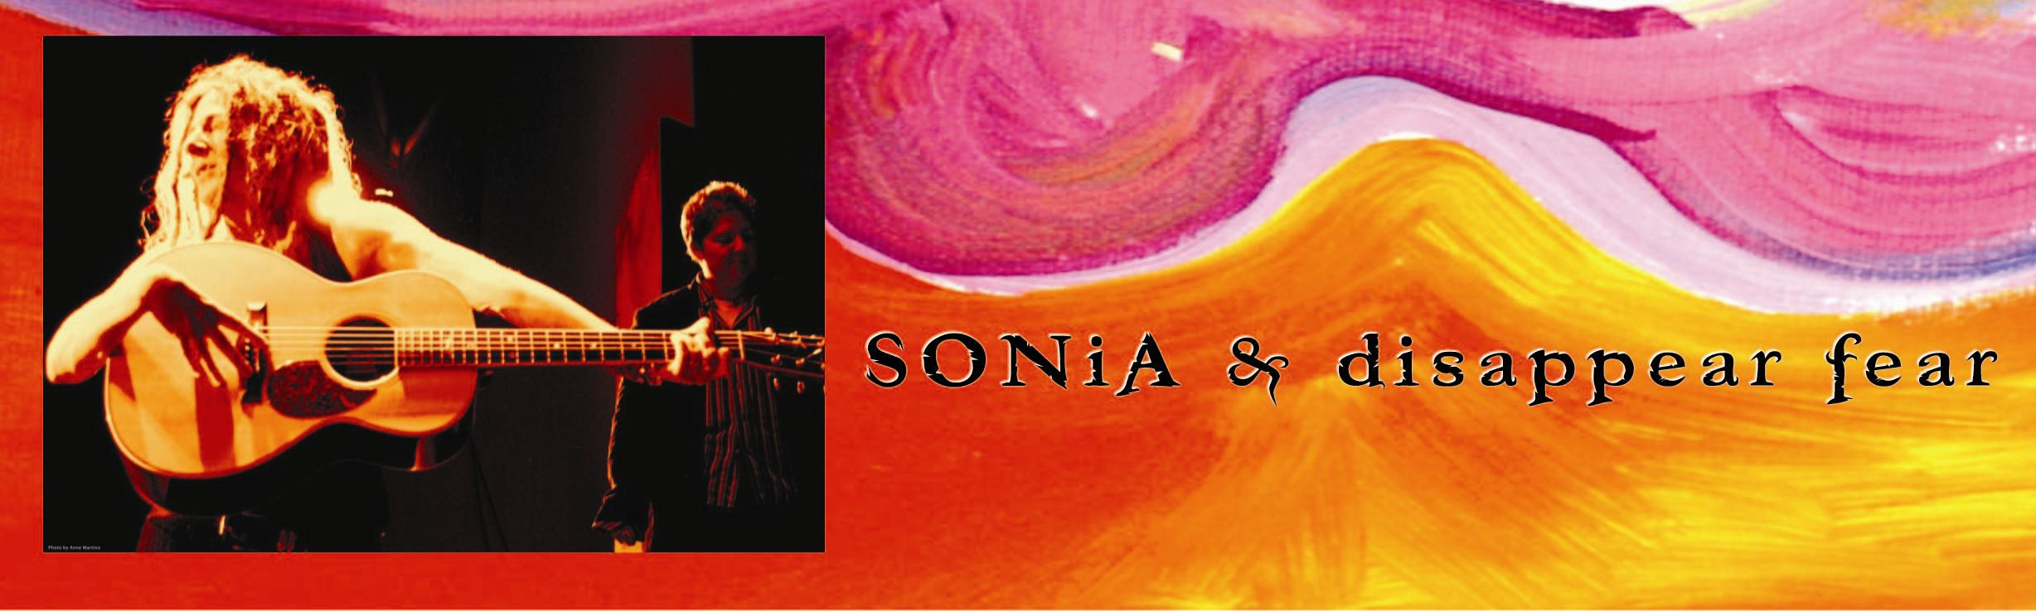

TRACK LISTING:  1. Telepatia Sexual [3:23]  (Sexual Telepathy)  2. La Tormenta Santa [2:50]  (The Holy Storm)  3. Mica Moca [3:15]  (Who is Greater)  4. Porque Estamos Aqui [4:37]  (Because We Are Here)  5. Shorashim [3:21]  (Roots)  6. Milliones de Cuerdas [2:53]  (Millions of Rope)  7. Un Medio de un Pulso [2:15]  (In the Middle of the Beat)  8. Metzotzim Anaquim [2:55]  (Big Giant Planes)  9. Cayendo [3:28]  (Fallin’)  10. Te Quiero [3:47]  (I Want You)  11. Se Tu Aquella [4:31]  (Be The One)  12. tango (Li Annaka) [3:19]  13. Big Giant Planes [2:55] |  | WASHINGTON POST MIKE JOYCE  “Rutstein's sensuous voice has a prominent place...” “...world beat charms and spiritual thrust.”  “...lean yet surprisingly colorful folk-pop arrangements.”  KAOS RADIO TACOMA, WA  ‘t a n g o’ by SONiA & disappear fear Ranked #6 in the Top 10 World Music Albums Soundroots/Spin the Globe, FALL 2007  WTMD RADIO PAUL HARTMAN  “this [t a n g o] is a genius work of art, I hope it gets the attention and credit it deserves”  SIRIUS SAT. RADIO LARRY FLICK  “t a n g o is fantastic, Wow!”  WYPR RADIO MARC STEINER  “that’s beautiful…a political and spiritual force”  WTJU RADIO SANDY SNYDER  “I got it [t a n g o] yesterday…it is terrific...I am dedicating an entire show to this CD”  KCSN RADIO LARRY WINES  “SONiA doesn’t just make world music, she makes music for the world.”  ROGER DIETZ WRITER FOR SING OUT!  “SONiA'S Tango is a masterpiece expressing the solitary romance of our softly moonlit ballroom. We are planetary partners holding on for dear life. It is the fond assurance of a true believer faithfully dancing in the glorious world of the hopeful lover. Tango presents perfectly created and recorded music that abounds with inspiration and exaltation. Here is an album that beats with the listener's heart and breathes with the humanity of a talented solo singer, along with the echo of every optimistic voice on earth. A whisper, a prayer, an embrace, and a song unsung…  until now. If the question is, "May I have this dance?" The answer is, Tango.”
“t a n g o” is SONiA & disappear fear’s dance with the world. Award winning American born singer/songwriter SONiA Rutstein composes 12 songs in Spanish, Hebrew, Arabic and English creating a Latin-Middle Eastern folk pop sound. True to her life long cause of a world without fear the songs weave personal trials of love and romance next to heartfelt political ideologies. The songs combine the indigenous sounds of djembes, tin whistles, violins and acoustic guitars, and resonate with the harmonies of disappear fear [SONiA along with percussionist/vocalist Laura Cerulli]. Making guest appearances are Rabbi Elizabeth Bolton and members of the original disappear fear band. Lyrics are included in a colorful 24 page booklet in all four languages over a colorful display of SONiA’s paintings.

RELEASE DATE:
FALL 2007

For a complete Press Kit Visit
www.disappearfear.com

FOR INFORMATION AND SCHEDULING INTERVIEWS
OR TO RECEIVE A FULL LENGTH VERSION OF THE CD:
Nancy Palmquist | 410.913.2773 | nancy@disappearfear.com

